This time, instead of writing an equivalent program in C, I looked to see if there was any pattern for numbers divisible by 8.

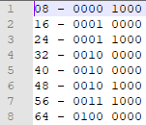

We can see that it seems numbers divisible by 8 do not have the 0th, 1st, or 2nd bits set. So, then we simply check if any of these are set, and if they aren’t, then we increment our counter. From here I essentially just repurposed the same program from last week. If we wanted to divide these numbers by 8($2^{3}$), we could just shift 3 to the right.

As for evidence that the program is working, here is a screenshot:

